For Immediate Release Press Contact: Tommy Bahama
Orsi Public Relations
Janet Orsi or Sara Pollock (323) 874-4073
janet@orsipr.com or sara@orsipr.com

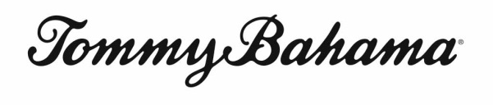

Tommy Bahama Announces 2012 Line-up of Major League Baseball Properties “Collector Edition” Shirts

Tommy Bahama and MLB gear up for the 2012 baseball season with six new team shirts and an expanded collection of baseball inspired sportswear

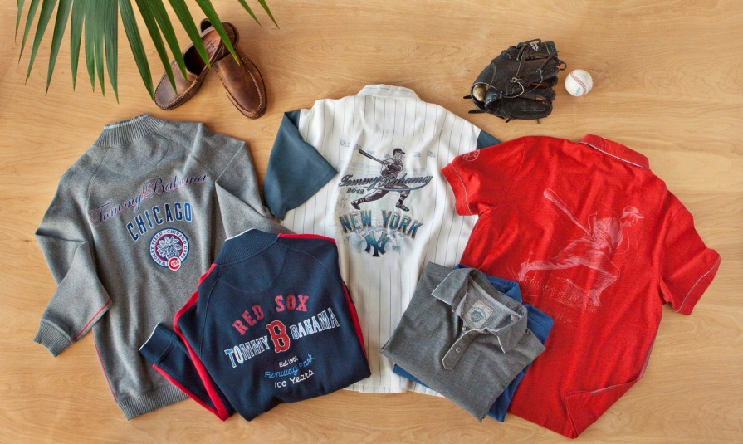
Two of America’s powerhouse lifestyle brands, Tommy Bahama® and Major League Baseball Properties, team-up again this year to provide fans with a new, expanded collection of co-branded apparel that pays homage to America’s favorite pastime while delivering authentic skybox style. For 2012, the roster for the “Collector’s Editions” shirts includes a Red Sox/Fenway Park shirt celebrating the historic ballpark’s centennial (available on opening day, April 5) followed by a Yankees Special Edition Shirt (April 12), and team shirts for the Texas Rangers (April 26), Detroit Tigers (May 3), Atlanta Braves (May 10) and a St. Louis Cardinals Commemorative World Series shirt (June 7). In addition to these six shirts, Tommy Bahama will also be releasing a 2012 All-Star Game shirt that has been specially created for the Midsummer classic, available at the end of May. The “Collectors’ Edition” shirts and the All-Star shirt are available only at select Tommy Bahama stores and at tommybahama.com.

Designed for a discerning fan-base, the first Tommy Bahama “Collector’s Edition” camp shirt was created to celebrate the 2009 World Series. Only a limited number of shirts were made, featuring a numbered label and sent with a collector’s certificate. Now, baseball fans and collectors of these exclusive designs have two reasons to look forward to Opening Day. Each season, Tommy Bahama unveils a new series of MLB team shirts with only a few teams featured. These shirts typically sell out so quickly they underscore the “Most Valuable” nature of these highly collectible shirts.

“Something truly special was created when we launched our first ‘Collector’s Edition’ shirt three years ago,” said Terry Pillow, CEO of Tommy Bahama. “Since then our customers have asked for more, and we have responded with an exciting new collection that pairs the signature style of the Tommy Bahama brand with the excitement and authenticity of Major League Baseball.”

- more -

Also for the 2012 season, Tommy Bahama will unveil some exciting new MLB themed sportswear that will give fans more stylish options than ever before. The line-up includes knit track jackets (currently available for nine teams), and a collection of half zip sweaters, pigment-dyed polos and signature camp shirt styles, customized for all 30 MLB teams with logos and offered at price points as easy-going as the designs themselves. Customized by market, fans can now celebrate their favorite teams, with new styles designed with Tommy Bahama’s legendary quality and finish, whether that’s a San Francisco Giants zip track jacket or a New York Yankees polo shirt.

“With this expanded collection, Major League Baseball Properties and Tommy Bahama have again brought the feeling of baseball alive just in time for Opening Day,” said Howard Smith, Senior Vice President, Licensing, Major League Baseball. “This exclusive collection is consistent with the quality of the Tommy Bahama brand and is designed specifically for fans who want to celebrate their favorite team in a fun and fashionable way.”

At Yankee Stadium, Tommy Bahama will also feature a unique offering of Yankees themed Tommy Bahama apparel at a new shop on the Luxury Suite Level. Other high-profile ballparks will also feature their team’s Tommy Bahama MLB sportswear prominently in their shops, including AT&T Park (Giants), Wrigley Field (Cubs), Coors Field (Rockies), Citizens Bank Park (Phillies) and Nationals Field (Nationals). Beyond the stadiums, fans can find Tommy Bahama’s MLB baseball inspired designs at Nordstrom, Lord & Taylor, select specialty stores and tommybahama.com.

# # #

ABOUT TOMMY BAHAMA
Tommy Bahama is owned by Tommy Bahama Group, Inc., a wholly owned subsidiary of Oxford Industries, Inc. (NYSE:OXM). Established in August 1992, with corporate headquarters in Seattle, Tommy Bahama is a lifestyle company that defines relaxed, sophisticated style in men’s and women’s sportswear, denim, swimwear, accessories and a complete home furnishings collection. Tommy Bahama is available at the country’s finest retailers, including Nordstrom, as well as high profile resort locations around the world. There are 96 Tommy Bahama retail locations across the country, 13 of which include a Tommy Bahama restaurant & bar. Additional stores will be opening this year. For more information, please visit www.tommybahama.com

